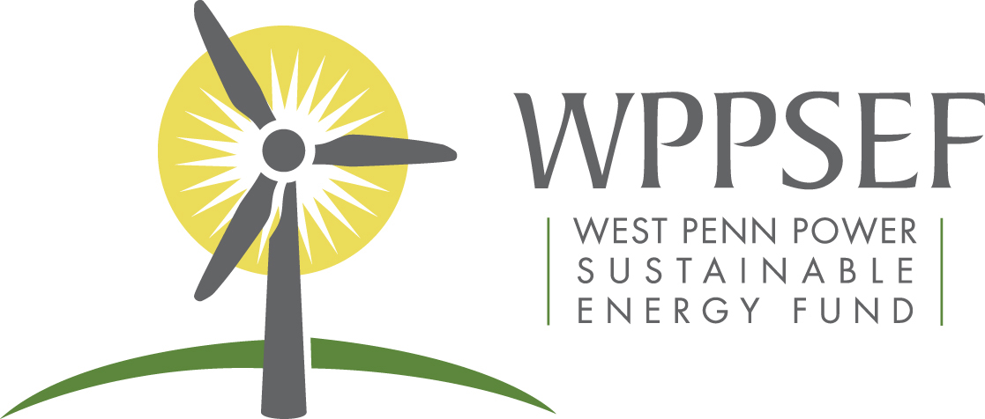

For immediate release
Contact John Ackerly, Alliance for Green Heat, 301-204-9562
jackerly@forgreenheat.org
Contact Barbara Robuck, West Penn Power Sustainable Energy Fund, 814-865-7380
wppsef@ems.psu.edu

West Penn Power Sustainable Energy Fund to support a design competition that pairs automated, electricity producing wood stoves with solar PV

June 27, 2018 - The Alliance for Green Heat received a $5,000 grant from West Penn Power Sustainable Energy Fund (WPPSEF) to support the 2018 Wood Stove Design Challenge, a competition to automate and make electricity from wood stoves from November9 - 13.

The grant funds will be used to test and promote stoves that are automated and produce electricity, both of which could be popular in Western Pennsylvania as they become more commercially available in the next few years. Twelve teams are competing and they will be rigorously tested for emissions, efficiency, electricity output and other qualities.,

Automated wood stoves can enable consumers to “load and leave” and get a high efficiency clean burn through sensors that can adjust by the minute and are far more effective than a human operator. Electricity producing stoves can recharge cell phones, power light bulbs in the event of a short or longer power outage caused by storms, grid failure or any other reason. Within 3 – 5 years, electricity producing wood stoves may also be a more common option in the northern US to complement low wintertime solar PV output. In the near future, thermoelectric wood stoves may be able to produce half as much electricity as solar PV in December and January in northern states.

Wood is a popular residential heating source in Pennsylvania. According to the latest Census figures, Pennsylvania has the highest number of households heating with wood outside New York and California. Approximately 3% of all homes in the Commonwealth use wood as a primary heating source, but in 16 counties, 10% or more of households use wood or pellets as a primary heat source according to the US Census: Fulton (20%), Sullivan (20%), Juniata (19%), Forest (16%), Potter (16%), Tioga (15%), Susquehanna (15%) and Bradford (14%), Bedford, (13%), Huntington (13%), Mifflin (13%), Perry (13%), Crawford (11%),Wayne (11%) and Warren (10%). More than half a million Pennsylvanians use it as a primary or secondary heat source.

“Woody biomass is an abundant renewable heat feedstock which has been used by generations to provide low-cost heating for homes across Pennsylvania. WPPSEF seeks to better understand how modern, innovative wood stoves can affordably help meet energy needs while operating far more cleanly than traditional wood stoves,” says Joel Morrison, Director of the WPPSEF.

The Alliance for Green Heat promotes modern wood and pellet heating systems as a low-carbon, sustainable and affordable energy solution. The Alliance works to advance cleaner and more efficient residential heating technology. The Wood Stove Design Challenge in November 2018 will the fourth Design Challenge hosted by the Alliance for Green Heat. Founded in 2009, the Alliance is an independent non-profit organization and is tax-exempt under section 501c3 of the tax code.
Learn more at http://www.forgreenheat.org/

The West Penn Power Sustainable Energy Fund (WPPSEF) is a 501(c)(3) nonprofit organization that invests in the deployment of sustainable energy technologies that benefit West Penn Power ratepayers in Pennsylvania. WPPSEF investments are focused in three broad categories:
- Deployment of sustainable and clean energy technologies;
- Deployment of energy efficiency and conservation technologies; and
- Facilitating economic development, environmental betterment, and public education as they relate to sustainable energy deployment in the WPP service region.
Visit http://www.wppsef.org for further information.

###

